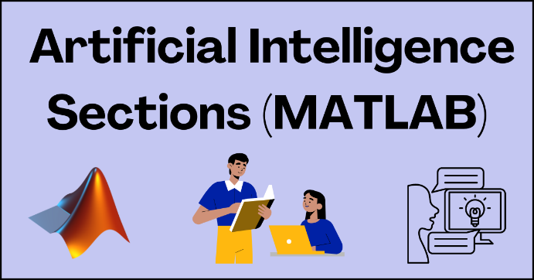

**PART 1**

Is it fair to use data to determine how much someone is willing to pay for a sports or concert ticket?

Watch this video on the $1000 dollar concert ticket

[Ticketmaster's Dynamic Pricing (youtube.com)](https://www.youtube.com/watch?v=mly_b1uoMoM)

Or this video on Sports pricing by the Buffalo Bills  
  
<https://www.buffalobills.com/video/watch-dynamic-and-variable-ticket-pricing-19304037>

Talk with each other and determine the answer to the following questions

1. What is Dynamic Ticket Pricing?

2. What data or parameters go into figuring out the cost of a ticket?

3. How much of the cost of the tickets for music concerts goes back to Ticketmaster? Is that fair to the artist?

**PART 2**

Read the deploy section of the main page, for “What is Sports Analytics” and “What is Music A & R Analytics.

**Part 3**

**TO DO:**

1. Watch this video where a music artist shows how to track fan engagement for their music on Spotify. They are using an external Data AI Tool called [MusicStax.](https://musicstax.com/)

[Dominate Spotify With These HIDDEN Metrics 🤫 (youtube.com)](https://www.youtube.com/watch?v=qLSONJE0YMU)

1. What is the popularity score- what specific data makes up the popularity score (1.59 mins in) What are the hidden metrics that goes into a popularity score?  What other metrics (information) does the program provide to the artist?

2. Pick two musical artists in the same genre that you like. Look up their metrics for popularity, energy, danceability, positiveness, speechiness, liveness, instrumentationess.  Compare the two. Who is the most popular and why do you think that is?

3. What kind of data do you think they use for energy, danceability, positiveness, speechiness, liveness, instrumentationess?

**Refine**

In the video above, at about 7:34 minutes in, the artist talks about the Discover Weekly Algorithm and how if you can get this to activate, then you can promote songs more.

4. What do you think an Algorithm is and what does it do here when it is triggered?  What data is it using?